

**WEB DESIGN AND DEVELOPMENT REPORT**

**–**

**DOT NET FOOTBALL CLUB WEBSITE**

Written by:

Emma Jane Heneghan – 10204278

And

Alexei Suleac - 10195788

Course code: B8IT058

Table of Contents

Table of Figures 3

Application Objective 4

Topic 4

Objectives 4

Usesrs of the Application 4

Hierarchical Structure 4

Visual Design 5

Database Design 6

XML 8

Technologies and Techniques used 8

Maintenance 9

SEO 9

Strengths and Weaknesses 9

Strenghts 9

Weaknesess 10

References 10

Individual contribution form – Emma Jane Heneghan 11

Individual contribution form – Alexei Suleac 16

Appendix A – SQL To Create Tables 19

Table 1 WebUsers 19

Table 2 WebTeamInfo 19

Table 3 WebJoinUs 20

Table 4 WebContactUs 20

Table 5 WebGameResults 21

Table 6 WebFixtures 21

Table 6 WebImages 21

Table 7 WebXML 22

Appendix B – SQL To Insert Values into Tables 23

Table 1 WebUsers 23

Table 2 WebTeamInfo 23

Table 3 WebJoinUs 24

Table 4 WebContactUs 24

Table 5 WebGameResults 24

Table 6 WebFixtures 24

Table 6 WebImages 25

# Table of Figures

Figure 1 - Default Page 5

Figure 2 - Design for all other pages 6

Figure 3 - SQL Server Management Database Diagram 8

Figure 4 - Sample of XML files generated 8

# Application Objective

## Topic

We have a multitude of football clubs in Ireland these days. In today’s world the running and managing of a club can require a lot of work and dedication. Football clubs need to be able to present all sorts of information related to club activities and news to people. They also need to manage trainings, matches and be able to communicate a lot of information to as well. Records of team members and staff members have to kept along with ability to update and remove those records.

## Objectives

The objective of our application is to design a web application that will be able to support running of a football club. We aim to give the ability to present the information to wide range of users, give the ability to communicate to people through the web site. Club member management, organising matches, releasing past matches results should be accommodated through the application.

# Usesrs of the Application

Our Web site aims at four general group of users:

1. General population looking at information about the club any future games and results. People that want to join the club or contact for any information.
2. Club members. These are the users that can upload pictures to the web site and view the lists of all current club members.
3. Administration users are people that will be able to add new members to the club. They will also be able to grand different access levels to all the users.
4. Coach. Users with this status will be able to add and remove fixtures. Add new game results, view received request to join the club and general contact queries.

# Hierarchical Structure

The web site is structured in such a way that user will have access to all parts of the site from any page they are currently on. Pages currently included are Home, About Us, Code of Ethics, Privacy Policy, Results and Fixtures, Team Profiles, Pitch Info, Join Us, Contact Us, Gallery, Login, Admin and SiteMap. Parts of application such as Admin page, are hidden from ordinary site visitors and only available to admin staff.

**Admins** can see the Admin page only when they log in to the web site, no other user can access that page. On this page they can view the list of all users and can change their access level. They can also add new team members from this page. On the Gallery page only Admin have the authority to delete images. On Contact us page they can view all the contact requests and mark them as seen if appropriate. On Team Profile page they will be able to see the list of all current team members. Admin are also the only group to see the Admin link in the navigation bar.

**Coaches** on log in and will be directed to Results and Fixture page. Here they can edit and amend the information regarding Results and Fixtures as necessary. Coaches also have access to contacts requests and joins requests on those respective pages. They can view the requests and mark as seen the accordingly.

**Players** when logged in are redirected to the Team Profile page. They have access to personal information (email and phone numbers) regarding all team members on Team Profiles page. Players can upload images as well as their own profile pictures.

**Other users** can see all other information with exception to information available only to player, coach and admin users. If a user attempts to view the admin page, they will only see a error message and no other information.

# Visual Design

The visual design for the Default Page is displayed in Figure 1. All other pages follow the design seen in Figure 2.

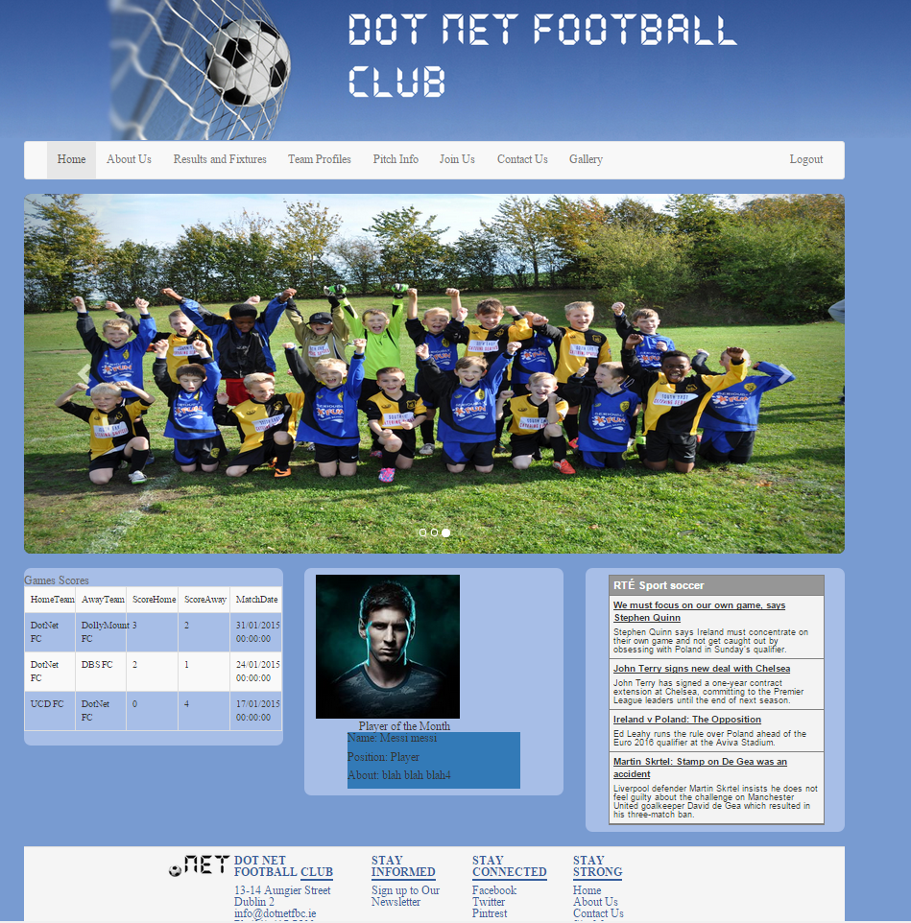

Figure - Default Page

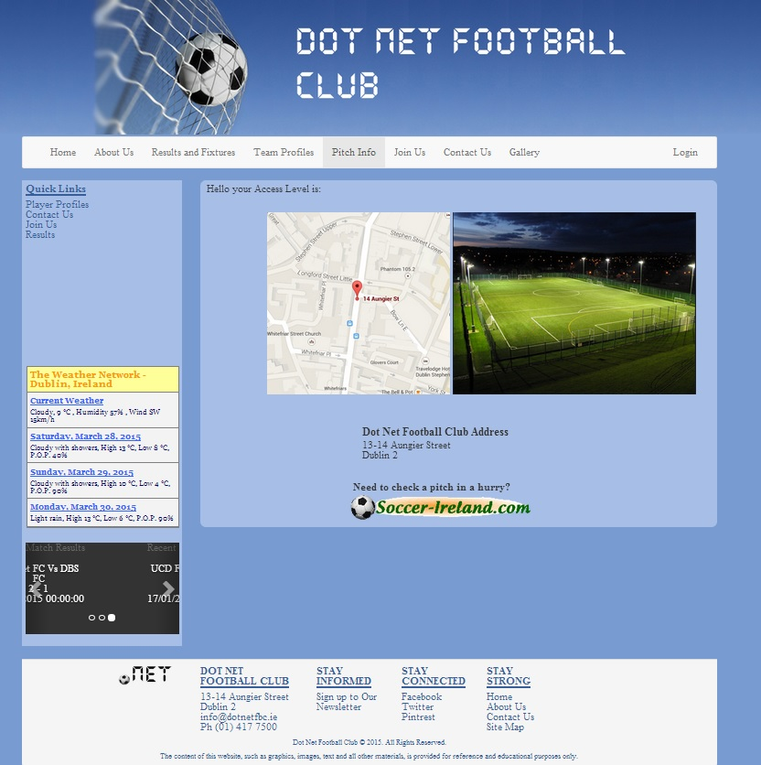

Figure - Design for all other pages

Design on all pages (except the Default page) is consistent with Figure 2. For the majority of pages we used two columns layout with left side bar providing quick navigation links and the latest score results. The Pitch Information page also includes RSS feed for the weather.

The reason we didn’t include side bar on our main page, is that we use a slider and as this is our main page, we the majority of navigations can be found in the navigation bar.

Colour scheme and fonts are consistent throughout the web site.

NOTE: we use message boxes and that doesn’t come up on top every time please when logging in so you need to click on small pop up and click ok.

# Database Design

Figure 1 displays the Database Table structure that was developed for this project. WebUsers table encapsulates information of users who have access to the website. WebTeamInfo table contains information on the team that will be displayed on the TeamInfo.aspx page. There is a one-to-one relationship between the WebUsers and WebTeamInfo. A record in the WeTeamInfo table cannot be created until a corresponding record has first been created on WebUsers table. The UserID is the primary key for WebUsers, and this is the foreign key in the WebTeamInfo table.

WebContactUs contains all enquiries captured on the ContactUs.aspx web page. WebJoinUs similarly captures the information of people interested in joining the team. These tables are displayed only when the coach is logged in, and the coach can change if the last column as they deal with enquires.

One function provided by the site is for a players, coaches and admin to upload images. Players and coaches can choose when they upload an image if it is their profile image for the TeamInfo.aspx web page. There is a one-to-many relationship between the WebTeamInfo and WebImages table. One record on the WebTeamInfo can be related to many records on the WebImages table.

Game results and future games are stored in WebGameResults and WebFixtures respectively. Only the coach has the authority to add and remove games from both tables. The results are then displayed in tables on the website for visitors to see, as well as the three most recent games in a slider in the side bar.

A WebXML table was created to capture an XML files created. The coach can create an XML file from the WebGameResults table, or from the WebTeamInfo table. Every XML file created is stored in a folder called XMLFiles in the Root directory, and is backed up on the database.

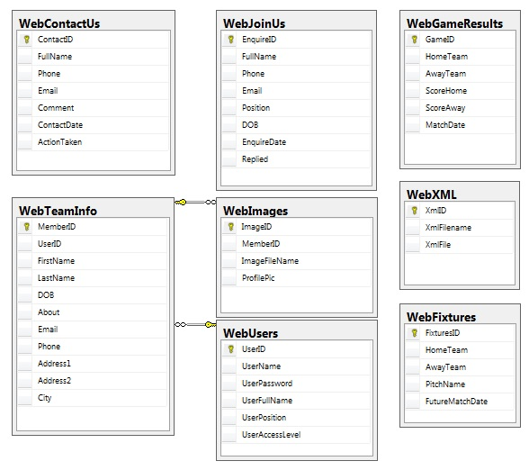

Figure - SQL Server Management Database Diagram

# XML

As mentioned in the Database Design Section, content can be stored as XML files. A table of Game results and Team Information are converted to XML with the view of making them easy to transfer across multiple platforms. An example of an XML file created is displayed in Figure 4 below.

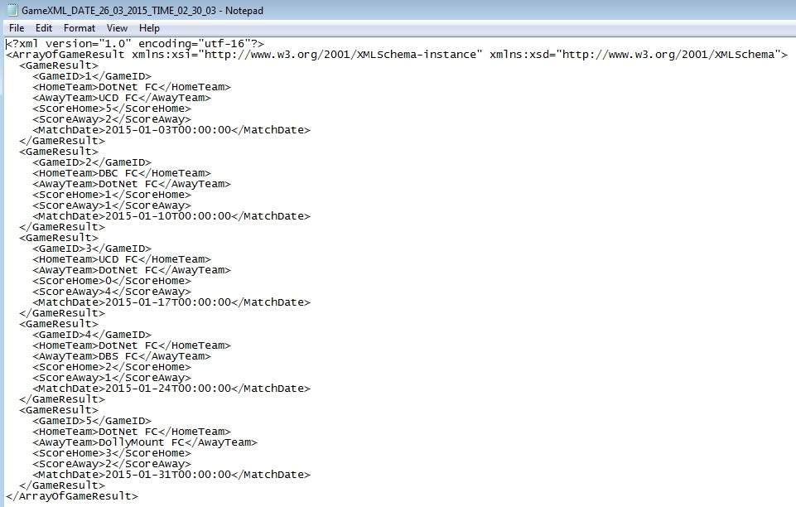

Figure - Sample of XML files generated

# Technologies and Techniques used

Main technologies used are the ones associated with ASP.NET, C# and are listed below:

HTML, CSS, JavaScript, JQUERY, C#, ASP.NET, JSON, AJAX, Entity Frameworks.

HTML is used for all our markup, CSS is used to apply some individual styles on the page. Bootstrap was also used to style and position some elements like gridview on our pages. JavaScript is used behind sign up for our newsletter.

JQUERY was used to process a JSON object and to populate the content of members on Team Profiles page. It targets a <div> element and inserts the data we want by using push. JSON object is provided by an AJAX enabled web service called JSONService.svc but it can just as easily be any web service available on the internet. The reason to use our own is to show how we can use JSON objects and use the data on our web site. Furthermore the data we get from that service is relevant in this application. The web service is accessing our database and retrieves the data that we need and makes it available as a JSON object.

For data access and all our CRUD operations we use Entity Frameworks. For that we needed to create a Context class that inherits from DbContext. For every table in our database we had to create a model class that would represent a model of one row in our database. Every class had to be configured to point to particular table in our database by using the same variable names as the names of columns in the database or providing appropriate annotations in order to ensure correct mapping. After that a variable of DbSet<objectType> objetS was created in our context class, to represent a particular table from our database. The Context class is then used throughout application to store, retrieve, edit and delete data from our database as necessary.

C# was used for all our server side processing such as manipulating data received from the database and pushing it in to our ASP web page.

In order to ensure that users can log in and out of the application and be able to access various parts of the web site we had to use SessionState. Here we created variables like following: Session["Username"] and used this to share information across all of our pages, and to filter our page content accordingly (e.g. admins access to admin page or coach access to edit results etc.).

# Maintenance

Maintenance can be performed on a website either on a regular basis or scheduled when needed. It can be performed with to improve site performance or for security reasons. When websites use the most up to date software, this keeps the website more secure, as well as improving the user experience to the site.

Regular site maintenance should be performed as updating the web page content and keyword information will cause search engines to return to your web site and will aid in search rankings.

# SEO

Several steps were taken to ensure website optimization. Within the siteMaster page, content placeholders were included so each page would specify their own clear and accurate page titles, and another content placeholder was included to give brief description in the meta tag of what that specific page contains.

For optimal SEO we have a clear and legible structure of files, which in turn ensure better URLs. The file names for each web page are relevant to the content being displayed. This way the URLs are easy for users to search and remember.

For our project we only included one site map. Usually two sitemaps would be generated, but as we are not hosting our website, we have not included an XML sitemap, which is used by search engines.

Users like content that is relevant and up to date. By ensuring that our content accurately portrays these criteria, our web site will have more repeat customers. Image optimisation is also very important as people are becoming more attuned to faster web sites. The loading time of each web page should take less than 2 seconds. According to Kissmetrics, 47 percent of visitors expect a website to load in less than 2 seconds, and 40 percent of visitors will leave the website if the loading process takes more than 3 seconds.

# Strengths and Weaknesses

## Strenghts

Validation is used on all text box fields, as well as regular expressions as required. This ensures that fields that must be entered to the database are captured and ensures good relevant data.

Each web page has its own unique meta tags, for description and keywords. They all share the same meta authors. Meta tags are an important part of SEO.

There is a good consistent design to our web application. Users want simple to understand and easy use interface which we have achieved in our persistent design. Our application does what we set it out to do and it does it well. All the controls are easy to use and easy to understand as they are self-explanatory.

Once the site is launched it responds very quickly, so the load time is very good. We provided various defence mechanisms for example if users point the browser to our admin page without being logged in as an admin they will get following message displayed “You do not have the correct Access Level for this page.”. Even if the user views the source code, they won't see any of the content that is available to the admin. Filtering users access to content is a good way to provide appropriate data access across our application.

When players upload profile pictures, the image must be 200 x 200 pixels. This ensures consistency which is a requirement of a good website.

## Weaknesess

When creating an XML file, there is no accountability of which coach created the file. Future work would be to amend the WebXML table to account for which user created the file.

XML sitemaps are used to let search engines know about all the pages that exist on a website that are available for crawling, which helps search engines index your content better.

Any user (who is not a guest) who has logged in can upload image. Future work would be to limit the image size that a user can upload for SEO.

Administration personnel currently can only change a team player or coaches “About” section either in the database directly or when site maintenance is being performed. Future work would be to add another option in the Admin page for administration personnel to update the DB directly.

# References

1. Sean Work . 2011. How Loading Time Affects Your Bottom Line. [ONLINE] Available at:<https://blog.kissmetrics.com/loading-time/>. [Accessed 27/03/2015].

# Individual contribution form – Emma Jane Heneghan

**Individual Contribution Form**

Assignment Topic: _ Database and Web Application Development______

Student No: _10204278___ Student Name: __Emma Jane Heneghan____

|  |  |
| --- | --- |
| **Dates** | **Tasks** |
| 24-2-2015 | * Set up BitBucket Repository for Web Assignment |
| 25-2-2015 | * Created Database Tables in Excel, pushed to BitBucket |
| 4-3-2015 | * Created the siteMaster for web pages, and defaultMaster for Default page, * Created the graphics for the header for all the web pages, * Added the connection string in the Web.config, * Imported Reset.css, * Imported Bootstrap.css, * Started on a nav bar for the web site * Created AboutUs, ContactUs, Default, Gallery, JoinUs, PitchInfo, ResultsNFixtures, TeamProfiles – aspx files, |
| 5-3-2015 | * Added footer, * Wrote the SQL for creating the Tables in SQL Server Management Studio, * Created a Work.xls file to keep track of work completed, |
| 12-3-2015 | * Wrote the INSERT INTO SQL statements to put values into the database tables |
| 13-3-2015 | * Deleted assignment, and created Web Forms assignment, * Created all the web forms with associated master pages |
| 14-3-2015 | * Added forms with Validation and Regular expressions to Contact Us and JoinUs web pages, * Added FileUpload to Gallery.aspx * Created Model folder, JoinUsForm.cs, ContactUsForm.cs, Gallery.cs, Context.cs, will all the associated code complete |
| 18-3-2015 | * Sending new record to DB from ContactUs.aspx, JoinUs,aspx, Gallery.aspx * Image upload saving new files to UserImages folder, * Imported Bootstrap navigation bar, applied to all pages |
| 19-3-2015 | * Added Login.aspx, * Added Login to Navigation bar, * Added Image for fade in background of all pages – CSS, * Added Favicon to Master pages, * Added Login Form on Login.aspx, Login.cs to Models folder * Included field Validation to all textboxes, * Added Alex Connection String to Web.config |
| 20-3-2015 | * Changed Login to LoginPage – due to errors, * Populated a GridView will a list of Current Users of the system, * Added form for new User to Register, * Included Validation on all textboxes, * Added in code to save new register record to DB, * Added LoginRegister.cs to Model folder, * Turned off all validation on Page_Load, Validation will occur on either button event – possible area to security concern, * Set Up a Session, where when a user logins in, their Username, MemberId and AccessLevel are saved in the SessionState, * Set the GridView visible=false, so only viewable to access level 1 – Admin, * Session State work successfully across all pages, * Made edits to SessionState in web.config to change the length of the session from 30mins to 5 mins, * Added a WelcomeLabel on all pages to test SessionState, * Added div viewable only by Admin to change users Access level, * In Gallery.aspx, using a ListView running at server and a method in associated code file, using an IQuerable method called GetImages to populate all the images stored in the UserImages folder to the screen, * Added in a div only the admin can access to delete images – currently only deleting row from DB, image still in UserImages folder |
| 21-3-2015 | * Added AdminPage, moved the DrigView and the option to changes a user’s access level from LoginPage to AdminPage, * Add Admin link in nav bar, only visible is Admin are logged in, * In nav bar, created two links with different ids, to show Login or Logout depending on if a user is logged in or out, * Added code across all web pages for Login/Logout display functionality, * In Gallery, added in code that deletes selected image from UserImages, * Added Quicklinks in side bars of all pages except the default page that doesn’t have a side bar, |
| 24-3-2015 | * Added a text slider to siteMaster to display at bottom of Side Bars, * Added CSS to style Slider, * Created method called GetForSlider in siteMaster that populates the slider with the three most recent match results * Added GridView viewable by coach on ConactUs and JoinUs pages so coaches can see any enquires * Added div to hide JSON object on TeamProfile.aspx, so that is not viewable to people viewing the site, or registered guests, * Created DBXML.xs in Model folder, * Added related code in Context.cs, * Created XMLFiles Folder, * Created associated table in SQL Server Database, * Added SQL code to SQL Tables.doc, * Added XML Button to ResultsNFixtues.aspx – button only visible by coach, * Added method called Serialize to serialize and object, * In btnXML_Click event, wrote code to Serialized list of Results to XML and save file in XMLFiles folder, * Added Similar XML button and functionality to TeamProfiles page, * Added RSSFeed for weather in sidebar of PitchInfo pg, * Added image of pitch location, that’s also a link to the actual location on google maps, |
| 25-3-2015 | * Added extra contentplaceholder in siteMaster page for a meta description tag – for SEO, * Added associated titles and page descriptions for all pages, * Added CodeOfEthics and PrivacyPolicy as web pages that are accessible from the AboutUs page via quick links or buttons * Added static content for CodeOfEthics and PrivacyPolicy pages, * Added associated CSS styling, * Added link to soccer-ireland for Pitch information to PitchIndo.aspx, * Added personal class “moveInEmma” to all divs to make them more aesthetically pleasing on every page, * Added column on SQL Serve JoinUs and ContactUs tables, * Added buttons on ConactUs page viewable only by coach to edit records as Seen or NotSeen, * Added similar function to the JoinUs page so the coach can keep track of which enquiry’s they’ve dealt with, * Added checkbox to Gallery.aspx so a player can specify if the image they are uploading is their profile pic to be displayed on the TeamProfiles / Default Page, * Added Assumptions to ReadMe.md, * Set div so only players, coach and admin can add images, not registered guests or visitors to the site, * Added defensive code to default page and TeamProfile so if no image is available, a default image is used for Player of the Month, * Set Server.Transfer so when a user logs in they are redirected to different pages, e.g. Admin to Admin page, * Added Static Club History to About Page, * Added Form to AdminPage, so Admin can enter players Team Information, * Successfully added meta description to all pages for SEO, * Edited CSS to ensure no white space on the bottom of any page, * Changed Registration so users Registering will be captured as guests, and not have the full capability as players, * Added validation for add new team player to Team tables, * Added code to ensure that there is no associated record for the team player the admin is added, before committing a record to the DB, |
| 26-3-2015 | * Created SiteMap.aspx, * Report Writing – SEO, Database Design, Weaknesses, Maintenance, XML, * Created Presentation slides under all headings of Report, * Added Presentation content for SEO, Database Design, Weaknesses, Maintenance, XML, * Added JavaScript behind the emailFunction() – to add a visitor to our newsletter, * Updated all SQL code, and included it as Appendix A and B in Report, * Added validation when a user uploads a profile picture, it must be 200 x 200 |
| 27-3-2015 | * Added Meta charset, Meta Keywords tag , and Meta author for better SEO |

Signed: _____Emma Jane Heneghan____________Date: _____27/03/2015______

We, the undersigned, confirm that the above is, in our opinion, a fair and true report.

Signature: _____Emma Jane Heneghan__________Date: _____27/03/2015______

Signature: _____Alexei Suleac _________________Date: _____27/03/2015_____

# Individual contribution form – Alexei Suleac

**Individual Contribution Form**

Assignment Topic: _____ Database and Web Application Development__________

Student No: _10195788______ Student Name: __Alexei Suleac________________

|  |  |
| --- | --- |
| **Dates** | **Tasks** |
|  | Agreed on content of the site and produced wireframes  Work done by Alex and Emma |
| 25.02.2015 | Research on how to use git  Created a document to share on how to use it. |
| 25.02.2015 | Initial wireframes are in project folder now |
| 26.02.2015 | Went over using git with Emma to make sure we both know how to use it. |
| 02.03.2015 | Created model classes and linked the tables |
| |  |  |  |  | | --- | --- | --- | --- | | 21.03.2015 |  |  |  | | Results and fixtures are now displayed on the site |
| 21.03.2015 | Working on main page slider |
| 22.03.2015 | Got JSON to work on the web site |
| 22.03.2015 | JSONService is now pulling data from db and populating the table on the page |
| 23.02.2015 | Selecting a member of the team on team profiles page works now |
| 23.02.2015 | Got images to display for a given member |
| 24.03.2015 | Styled Team Profiles page |
| 25.03.2015 | Completed main page. Slider displaying correctly, results table with last 3 results is displayed, player of the month profile is displayed, football news rss are displayed. |
| 25.03.2015 | Admin and coach info is not displayed on tem profile page |
| 25.03.2015 | Coach can now delete a fixture |
| 26.03.2015 | Adding new fixture works now |
| 26.03.2015 | Added more styling. Adding new score now works. Added an alert after inserting new score to inform the user of changes |
| 26.032015 | Created Report document with relevant sections to work on. |
| 26.03.2015 | Filled in relevant parts of the report |
| 26.03.2015 | Filled in relevant parts of presentation |
| 27.03.2015 | Added delete option for fixtures to gridview and removed the button that was used to this before |
| 27.03.2015 | Added the same delete option to results gridview |
| 27.03.2015 | Changed the displaying of input fields on results and fixture page |
| 27.03.2015 | Added regex validation to new fixture option |
| 27.03.2015 | Added regex validation for new results option |
| 27.03.2015 | Added regex validation to create new team member on admin page |
| 27.03.2015 | Changed regex validation rules on contact us and join us pages |

Signed: ___Alexei Suleac ___________________Date: ____27/03/2015­­________

We, the undersigned, confirm that the above is, in our opinion, a fair and true report.

Signature: ___Alexei Suleac____________________Date: ____27/03/2015­­________

Signature: ____Emma Jane Heneghan_ _________Date: _____27/03/2015­­­­_______

# Appendix A – SQL To Create Tables

## Table 1 WebUsers

CREATE TABLE WebUsers

(

UserID INTEGER IDENTITY (10201, 1) NOT NULL,

UserName NVARCHAR(50) NOT NULL,

UserPassword NVARCHAR(50) NOT NULL,

UserFullName NVARCHAR(100) NOT NULL,

UserPosition NVARCHAR(50) NOT NULL,

UserAccessLevel NVARCHAR(50) NOT NULL,

CONSTRAINT PK_WebUsers PRIMARY KEY(UserID)

)

GO

## Table 2 WebTeamInfo

CREATE TABLE WebTeamInfo

(

MemberID INTEGER IDENTITY (123123, 1) NOT NULL,

UserID INTEGER NOT NULL,

FirstName NVARCHAR(50) NOT NULL,

LastName NVARCHAR(50) NOT NULL,

DOB DATE NOT NULL,

About NVARCHAR(255) NOT NULL,

Email NVARCHAR(100) NOT NULL,

Phone NVARCHAR(20) NOT NULL,

Address1 NVARCHAR(50) NOT NULL,

Address2 NVARCHAR(50) NOT NULL,

City NVARCHAR(50) NOT NULL,

CONSTRAINT PK_WebTeamInfo PRIMARY KEY(MemberID),

CONSTRAINT FK_UserIDFromWebUsers FOREIGN KEY(UserID)

REFERENCES WebUsers(UserID)

)

GO

## Table 3 WebJoinUs

CREATE TABLE WebJoinUs

(

EnquireID INTEGER IDENTITY (1, 1) NOT NULL,

FullName NVARCHAR(100) NOT NULL,

Phone NVARCHAR(20) NOT NULL,

Email NVARCHAR(100) NOT NULL,

Position NVARCHAR(50) NOT NULL,

DOB DATE NOT NULL,

EnquireDate DATETIME NOT NULL,

Replied BIT,

CONSTRAINT PK_WebJoinUs PRIMARY KEY(EnquireID)

)

GO

## Table 4 WebContactUs

CREATE TABLE WebContactUs

(

ContactID INTEGER IDENTITY (1, 1) NOT NULL,

FullName NVARCHAR(100) NOT NULL,

Phone NVARCHAR(20) NOT NULL,

Email NVARCHAR(100) NOT NULL,

Comment NVARCHAR(255) NOT NULL,

ContactDate DATETIME NOT NULL,

ActionTaken BIT,

CONSTRAINT PK_WebContactUs PRIMARY KEY(ContactID)

)

GO

## Table 5 WebGameResults

CREATE TABLE WebGameResults

(

GameID INTEGER IDENTITY (1, 1) NOT NULL,

HomeTeam NVARCHAR(100) NOT NULL,

AwayTeam NVARCHAR(100) NOT NULL,

ScoreHome INTEGER NOT NULL,

ScoreAway INTEGER NOT NULL,

MatchDate DATETIME NOT NULL,

CONSTRAINT PK_WebGameResults PRIMARY KEY(GameID)

)

GO

## Table 6 WebFixtures

CREATE TABLE WebFixtures

(

FixturesID INTEGER IDENTITY (1, 1) NOT NULL,

HomeTeam NVARCHAR(100) NOT NULL,

AwayTeam NVARCHAR(100) NOT NULL,

PitchName NVARCHAR(100) NOT NULL,

FutureMatchDate DATETIME NOT NULL,

CONSTRAINT PK_WebFixtures PRIMARY KEY(FixturesID)

)

GO

## Table 6 WebImages

CREATE TABLE WebImages

(

ImageID INTEGER IDENTITY (10001, 1) NOT NULL,

MemberID INTEGER NOT NULL,

ImageFileName NVARCHAR(50) NOT NULL,

ProfilePic BIT,

CONSTRAINT PK_WebImages PRIMARY KEY(ImageID),

CONSTRAINT FK_UserIDFromWebTeamInfo FOREIGN KEY(MemberID)

REFERENCES WebTeamInfo(MemberID)

)

GO

## Table 7 WebXML

CREATE TABLE WebXML

(

XmlID INTEGER IDENTITY (10001, 1) NOT NULL,

XmlFilename NVARCHAR(50) NOT NULL,

XmlFile NVARCHAR(MAX) NOT NULL,

CONSTRAINT PK_WebXML PRIMARY KEY(XmlID),

)

# Appendix B – SQL To Insert Values into Tables

## Table 1 WebUsers

INSERT INTO WebUsers(UserName, UserPassword, UserFullName, UserPosition, UserAccessLevel)

VALUES

('Alex', 'alex', 'Alex Smith', 'Admin', 'level1'),

('Emma', 'emma', 'Emma Black', 'Admin', 'level1'),

('Sam', 'sam', 'Sam Jones', 'Coach', 'level2'),

('Messi', 'messi', 'Lionel Messi', 'Player', 'level3'),

('Joe', 'joe', 'Joe Bloggs', 'Player', 'Guest'),

('George', 'george', 'George Best', 'Player', 'level3'),

('Cris', 'cris', 'Cristiano Ronaldo', 'Player', 'level3'),

('John', 'john', 'John Rowley', 'DBS Lecturer', 'level1')

## Table 2 WebTeamInfo

INSERT INTO WebTeamInfo(UserID, FirstName, LastName, DOB, About, Email, Phone, Address1, Address2, City)

VALUES

(10201, 'Alex', 'Smith', '1980-01-02', 'Alex is part of the Admin team.', 'alex@dotnet.ie', '087-1234567', '12 Dame St', 'Dublin 2', 'Dublin'),

(10202, 'Emma', 'Black', '1987-07-29', 'Emma is part of the Admin team.', 'emma@dotnet.ie', '087-1231231', '1 Quays Ave', 'Dublin 1', 'Dublin'),

(10203, 'Sam', 'Jones', '1985-04-01', 'Same has been a coach for the last 20 years.', 'sam@dotnet.ie', '086-7897897', 'The Grand Lodge', 'Rathoath', 'Meath'),

(10204, 'Lionel', 'Messi', '1987-06-24', 'Lionel Andrés Messi Cuccittini is an Argentine professional footballer. He is a forward and serves as captain for Argentina.', 'messi@dotnet.ie', '085-456456', '123 Barcelona St', 'Dublin 12', 'Dublin'),

(10205, 'George', 'Best', '1987-06-24', ' George Best was a Northern Irish footballer who played as a winger for Manchester United and the Northern Ireland national team.', 'george@dotnet.ie', '085-456456', '12 Barna St', 'Dublin 52', 'Dublin'),

(10206, 'Cristiano', 'Ronaldo', '1977-06-21', ' Cristiano Ronaldo dos Santos Aveiro, GOIH, known as Cristiano Ronaldo, is a Portuguese professional footballer.', 'cris@dotnet.ie', '085-456456', '75 Okland St', 'Dublin 12', 'Dublin'),

(10207, 'John', 'Rowley', '1992-01-01', ' C# .net Developer, Experienced Web Development Trainer (PHP, SQL, Javascript, .NET (C#), Zend Certified PHP Developer', 'cris@dotnet.ie', '085-456456', '75 Okland St', 'Dublin 12', 'Dublin')

## Table 3 WebJoinUs

INSERT INTO WebJoinUs(FullName, Phone, Email, Position, DOB, EnquireDate, Replied)

VALUES

('Joe Bloggs', '087-1231237', 'joe@eircom.ie', 'Goalie', '1982-01-09', '2015-02-28', 0),

('Nathan Downey', '087-1111231', 'nathan@eircom.ie', 'Forward', '1985-09-29', '2015-02-22', 0)

## Table 4 WebContactUs

INSERT INTO WebContactUs(FullName, Phone, Email, Comment, ContactDate, ActionTaken)

VALUES

('Mark Johnson', '087-1234444', 'mar@eircom.ie', 'balh blah comment 1', '2015-02-28', 0),

('Patrick Green', '087-1111333', 'patrick@eircom.ie', 'blah blah comment2', '2015-02-22', 0)

## Table 5 WebGameResults

INSERT INTO WebGameResults(HomeTeam, AwayTeam, ScoreHome, ScoreAway, MatchDate)

VALUES

('DotNet FC', 'UCD FC', 5, 2, '2015-01-03'),

('DBC FC', 'DotNet FC', 1, 1, '2015-01-10'),

('UCD FC', 'DotNet FC', 0, 4, '2015-01-17'),

('DotNet FC', 'DBS FC', 2, 1, '2015-01-24'),

('DotNet FC', 'DollyMount FC', 3, 2, '2015-01-31')

## Table 6 WebFixtures

INSERT INTO WebFixtures(HomeTeam, AwayTeam, PitchName, FutureMatchDate)

VALUES

('DotNet FC', 'Trinity FC', 'Alfie Byrne Road', '2015-05-03'),

('DCU FC', 'DotNet FC', 'Herbert Park', '2015-05-10'),

('Trinity FC', 'DotNet FC', 'Kilmore Drive', '2015-05-17'),

('DotNet FC', 'DCU FC', 'Alfie Byrne Road', '2015-05-24'),

('DollyMount FC', 'DotNet FC', 'st Annes Pitch 21', '2015-05-31')

## Table 6 WebImages

INSERT INTO WebImages(MemberID, ImageFileName, ProfilePic)

VALUES

(123126, '6fe30da0-da03-4eb9-ae43-2dc3a85f7ebe-messi.jpg', 1),

(123127, 'dfd01b6c-6dbe-4e66-a7fc-dbdf27683c80-george.jpg', 1),

(123128, '1b169f03-0a4d-4ccc-9e54-6503071c2ee5-cris.jpg', 1)